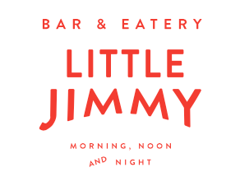

Valentine’s Day 2021
Choice of
West Coast trevally, coconut, lime, chili (df,gf)
Pork & potato croquettes, soy honey glaze, pickled onions
Cashew kofta, hummus, avo smash, radish (gf,df,v)

Choice of
Pan fried market fish, capsicum, spring onion, romesco, chimichurri (df,gf)
Freedom Farms pork belly, apple & fennel, gastrique, baby kale (df,gf)
Goat loaf, pistachio, courgette, pickled onions (gf)
Spinach & potato gnocchi, potabello mushrooms, truffle (v,df)

Ruby red grapefruit sorbet (v,df)

Choice of
Dulce de Leche cheesecake, chocolate soil, fresh berries, kiwifruit sorbet (gf)
Warm sticky date pudding, butterscotch, vanilla ice cream

Sides as extras
Curly fries, chipotle aioli 10 Chargrilled sweetcorn 12 Apple and carrot slaw 10

